1. Remove redundant Search Box from admin dashboard.
2. We need the Exchange Cost row in DRS after “Net Deposit after Client Balance”.
3. Give the option to add opening balance in the Exchange Cost Section manually.
4. When we download the dashboard report in Excel format, in the highest winner and highest looser segment, amounts are missing and misplaced. SS attached for reference.  
     
   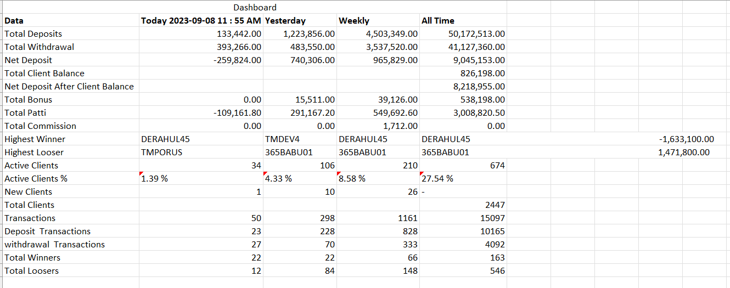
5. In My Master Data>Agents, remove the Mobile Number column.
6. In My Master Data>Agents, Agent’s Patti & Commission keeps changing over time. Therefore we need an option of adding/editing Patti & Commission with effect from a specific date.
7. In My Master Data>Clients, Promo Codes are added when the client makes their first deposit. But sometimes agents request us to remove a client from their code or even tell us to add that client back in their promo code. In such cases it is very important that while editing the client we get to add or remove promo codes with effect from a specific date.
8. In My Master Data>Expenses add the option of uploading expenses via excel sheet. There should be an option to download sample file and then upload it with data
9. In Payment Management, I need to see the result of entries that I am making right below the submission of entry.
10. Filters need to be streamlined for all the columns of ID Transactions and Bank Transaction tables. There should be an option to filter and search every column.
11. Bonus Column is not visible in the downloaded report of ID Transactions and Bank Transaction
12. In Profit & Loss, we need following columns like DRS (do no remove the existing date filter from Profit & Loss):
    1. Today
    2. Yesterday
    3. Current Week
    4. Last week
    5. Till Date
13. In Profit & Loss, Available Balance should be deducted from Net Deposit to arrive at Net Deposit after Client Balance.
14. In Profit & Loss, After deducting Exchange Cost we will get Gross Profit. From this Gross Profit we will deduct Expenses and Get Net Profit.
15. Exchange Cost must be calculated by multiplying every entry with the percentage of that exchange. For example, if a client deposits 10000 in DIAMOND EXCH then our exchange cost for that deposit is 2200 because DIAMOND EXCH’s cost is 22% for us. SImilarly, if a client withdraws 10000 in DIAMOND EXCH then our exchange cost for that withdrawal is -2200. This negative value of withdrawal will be deducted from positive values of deposits and at the end we will get the net cost of using that exchange.
16. In the CSV Management>CSV upload section, We need downloadable sample files for all exchanges.
17. In the CSV Management>CSV upload section show me the list of pending uploads till date.
18. In the CSV Management>CSV Transactions section, we need all filters and download option
19. In the CSV Management>View Settling>Promo Code Wise Report, we need The column of Net Deposit after the columns, deposit and withdrawal. Bonus column should be mentioned after the Net Deposit.
20. In the CSV Management>View Settling>Promo Code Wise Report, we need the report to be more presentable using colours, borders and bold fonts.   
    Example: (Not Possible)  
      
    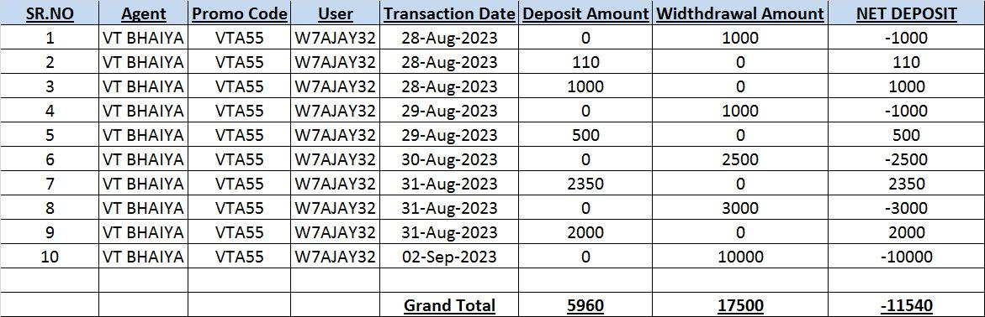
21. The CSV Management>View Reconciliation Section should also be visible to DEO as well as Supervisor login.
22. In the Reports section, Agent Summary, needs to be specifically agent wise. Right now we have repeated the names of the same agents over and over again. Also the Payable column in Agent Summary is showing incorrect data. Please discuss the methodology of calculation applied.
23. In the Reports section, In Weekly Summary, calculation of Average Deposit and WIthdrawals is incorrect.
24. In the Reports section, In Weekly Summary, calculation of Agent Patti and Commission and Exchange Upline Pay is incorrect or non-existent.
25. In the Reports section, Daily Agent Report there should be an option of selecting multiple Agents and downloading their reports in bulk.
26. Need following additional reports:
    1. Line Chart showing Growth of Deposits, Withdrawal and Net Deposits (Of the chosen time period) (Existing chart is unreadable and gives wrong representation of data)
    2. Bar Chart showing share of Agents in Deposits/Withdrawal/Net Deposits (Of the chosen time period)
    3. Bar Chart showing share of Agents vs Own Deposits/Withdrawal/Net Deposits (Of the chosen time period)
    4. Expenses Report showing head wise and sub head wise total of expenses in a given time period.